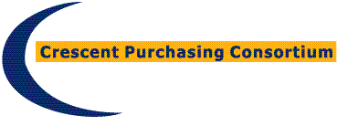

Access Agreement
Multifunctional Devices and Digital Transformation Solutions Framework - CPC/DU/MFD/03A
This is a confirmation of access to the Multifunctional Devices and Digital Transformation Solutions Framework, and an agreement of commitment to use said Framework.
Framework User Contact:  Name:  Email:  Tel: | Supplier Contact:  Name:  Email:  Tel:

Framework Start Date xx xxxxxxxxxx 2021*
Length of Framework Agreement: 3 years with the option of a 1 year extension.*

This is an agreement to confirm [enter Framework User name] has satisfied itself of its eligibility to utilise the Framework. Signature of this form constitutes acceptance of the Framework Agreement Call-Off Contract Terms and Conditions which are enclosed, thereby creating a binding commitment to the utilisation of a Call-Off Contract from the framework agreement referenced above.
We agree to enter into a Call-Off Contract as from [enter date of commence], for a period of [years/months] commences from the date of signature of this Access Agreement.
On behalf of the supplier: [enter supplier name]
Contact Name:
Telephone number:
Email Address:
Signature:
Date:

On behalf of [enter Framework User name]
Contact Name:
Telephone number:
Email Address:
Signature:
Date:

A completed copy of this form should be emailed to the contract manager Steve Davies at steve.davies@npg-ltd.com.

