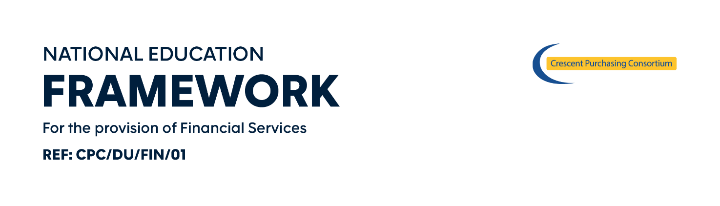ORDER FORM

[_______________] (the End User) wishes to procure the below mentioned Services from [_______________] (the Supplier), commencing on [________________] and ending on [________________] /continuing for a minimum period of [___________] months (delete as applicable) unless varied in accordance with the Call-Off Contract Terms and Conditions.
The definitions that apply to the Agreement also apply to this Order Form.
This Order Form is issued under the Call-Off Contract Terms and Conditions (“Agreement”). Customers can use this Order Form to specify the Service requirements they wish to order. The execution and return of this Order Form by the End User to the Supplier forms a Contract which is legally binding agreement between the parties. A copy of which (as appropriate) has been provided to the End User and is also available via the framework Help Desk at info@eduframeworks.co.uk.
The Agreement applies to the exclusion of all other terms including, without limitation, any terms appearing on a purchase order of which the Supplier seeks to impose or incorporate, or which are implied by trade, customer, practice or course of dealings.
End User Site
Address for Receipt of Solution | Invoice Address (if different)
Post Code | Post Code
Contact Name (PRINT) (Mr/Mrs/Miss/Ms/Dr/Rev):
Tel No: | CPC Member No.
Email: | Fax No:
Delivery Date: | Installation Date (if different):
Signature (End User)  Name and Position (End User) |  | Date:
Signature (Supplier) |  | Date:

Sheet 2 of __
The Service being purchased is detailed [below/within the attached document entitled [_______________]] (delete as appropriate).
Service |  | Price (ex VAT) | Price (inc VAT)
Services (insert below details of the services being delivered)
TOTAL PRICE |  | £_________________________ excl VAT
A completed copy of this form should be emailed to the Helpdesk at
info@eduframeworks.co.uk

Please note this information will be kept confidential and will only be used for internal framework monitoring and management purposes.

CONTRACT No CPC/DU/FIN/01
Contract for the Provision of Financial Services

